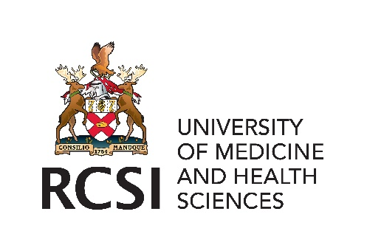
THE ROYAL COLLEGE OF SURGEONS IN IRELAND
ATLANTIC SURGICAL LEADERSHIP EXCHANGE PROGRAMME
SHORT TERM CLINICAL VISIT TO
VIET DUC HOSPITAL, HANOI, VIETNAM, 2024/25

Attach Passport size

APPLICATION FORM
(Please complete in print/type)

Note: This programme is available to ST 3-8 surgical trainees only.

PERSONAL DETAILS
Name in full:
List qualifications:
Present Address:
Contact Tel. No.: Email address:
Date of Fellowship/Membership of the Royal College of Surgeons in Ireland:
Date of Birth:
Present Post:
Consultant Supervisor:
Specialty:
Name of Training Programme Director (please enclose letter of approval):
Insurance cover other than Clinical Indemnity Scheme (namely MPS):
Describe how you will benefit professionally from this programme (maximum 150 words)
SIGNATURE
Signature: Date:

One hard copy and one electronic copy of completed application form together with updated curriculum vitae, letter of support from two referees and proof of personal insurance (eg. MPS) forwarded to:

Mr. Fergal O'Rourke
Administrative Assistant
Institute of Global Surgery
School of Population Health
Beaux Lane House
Lower Mercer Street Dublin 2
D02 DH60
E: FergalAORourke@rcsi.ie
T: +353 87 631 3082

