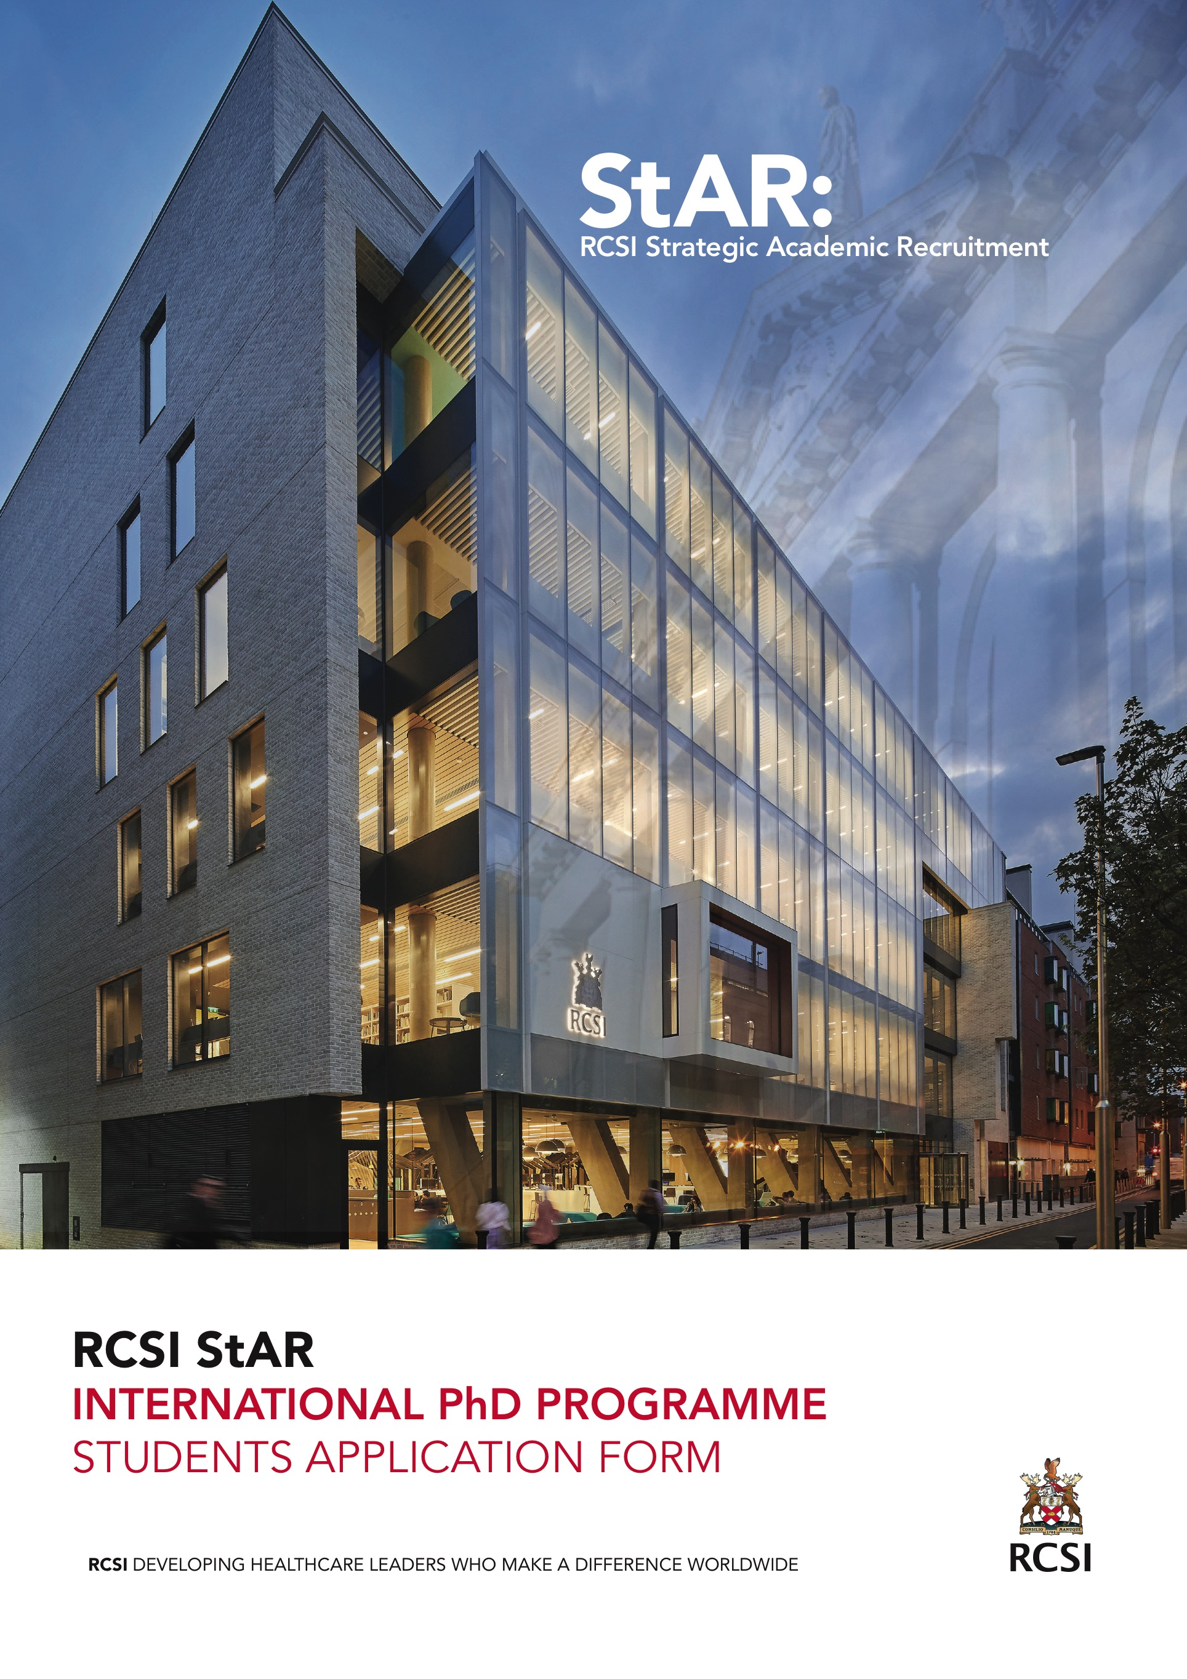

RCSI STAR INTERNATIONAL PHD PROGRAMME
RCSI's Strategic Academic Recruitment (StAR) Programme is now offering up to 4 prestigious fully funded PhD scholarships. This programme aims to attract high-achieving international scholars to an efficient four-year structured PhD training programme at RCSI.

The RCSI StAR PhD Programme aims to encourage scientists to develop innovative research projects in one of RCSI’s areas of research strength:
- Neurological and Psychiatric Disorders
- Population and Health Systems
- Regenerative Medicine (Bioengineering)
- Translational Cancer
- Vascular Biology
- Respiratory Medicine
- Pharmacy, Pharmaceutical Sciences & Chemistry
- Infection, Immunity and Inflammation
- Nursing and Physiotherapy

RCSI
- At the forefront of educating healthcare professionals since 1784.
- Ireland’s only focused health sciences institution & largest medical school
- One of the leading health sciences institutions in the world.
- Students from >80 countries and 4 overseas campuses (including RCSI-Bahrain and RCSI-Dubai),
- Global reach through our network of alumni in 97 countries
- Ranked in the top 2% of universities worldwide (2019 THE World University Rankings)
- Ranked joint 2nd of 9 institutions in Ireland.
- Ranked 1st in Ireland for publication citations
- Field-weighted citation impact that is twice the world average
- Highest success rate for Horizon 2020 applications from an Irish institution (RCSI; 28%, EU and Ireland average: 15%).

BENEFITS
- Opportunity for an international research training experience in a world class institution
- Four-year structured PhD training programme with the opportunity to gain an additional Professional Certificate in Research Practice
- Funded four-year PhD Scholarship, covering scholar fees, tax-free stipend (€18,000 p.a.) and laboratory consumables.
- Relocation package: up to €5,000 per scholar
- Annual home travel allowance: ~€300-€800 p/a – depending on EU/Rest of World

PURPOSE
The RCSI StAR PhD Programme aims to encourage scientists to develop innovative research projects in the field of Health Sciences. Scholars will choose their preferred research project from the list of available projects here.

PROGRAMME
This structured training programme will include compulsory core modules in ethics, science communication, biostatistics and intellectual property. Core modules are complemented by many additional optional modules delivering skill sets including innovation and entrepreneurship, data management, coding. Depending on the number of modules a scholar takes during their PhD, they may qualify for a Professional Certificate in Research Practice. The structured training is designed to suit bench scientists, informatics-based research, clinical researchers, and population heath.
ELIGIBILITY
The PhD Programme is designed for high achieving international scholars with a strong profile and a background in Biomedical Research, Clinical Research, Population Health Research, or Health Services Research coming from primary degree courses focusing on: Cell and Molecular Biology; Clinical and Translational Sciences; Medical Sciences; Bioengineering; Pharmacy; Physiotherapy; Nursing and Midwifery; Medicinal Chemistry; Genetics and Neurosciences; Population Health; Social Sciences; Health Services Research; Education in Health Sciences. Scholars will have obtained or be about to obtain a 1st Class Honours degree or equivalent (i.e. top 10 % of primary degree - or equivalent) and should provide a grade point average (GPA) for each completed year of undergraduate degree. English requirements: IETLS ≥6.5 or must have completed primary degree through the medium of English. Scholars can be from any country in the world, there are no restrictions on nationality.

APPLICATION PROCESS
Details of available research projects and application portal will be available from 11 October 2019 at www.rcsi.ie/StARPhD. Students must submit this application form (detailing academic progress to date, CV/Resume and a brief motivational statement describing your career plans) and a recent transcript from degree awarding institution.

Applications Open | 11 October 2019
Applications Close | 2 December 2019  (17:00 GMT)
Interviews | January 2020
4 year PhD Position begins | October 2020

ENQUIRIES
For informal enquiries or questions about the application process, please contact starphd@rcsi.ie.

(Please complete and save as PDF)
Applicant Name
University
(include QS/THE ranking)
Course of Study
Year of Study
Nationality
Gender
Email
1st year (overall GPA)
2nd year (overall GPA)
3rd year (overall GPA)
Current class rank
Preferred research projects (1-3). See Call Document online. | 1
 | 2
 | 3

CV/Resume (1 page max)

Motivational statement and career plans (1 page max)

Signature of Applicant

NOTES
- QS University rankings available at https://www.topuniversities.com
- THE University rankings available at https://www.timeshighereducation.com
- Please provide a grade point average (GPA) for each completed year of your undergraduate degree. For your current year, the GPA for Semester 1 should be provided. If your university does not use grade point averages, a useful tool to calculate your GPA is available at https://www.foreigncredits.com/resources/gpa-calculator/ . If you are converting your grade to a GPA, please also indicate your grade and the grading scale used by your university.

